HOUSE BILL-SOP
House Bill Documents contains the following information
- Appraisal Evidence Summary
- Property Description
- Equity Analysis
- Neighborhood details (Comparable Sales)
- Maps/Photos
House Bill process could be help for file prep team to prep the accounts with all comparable sales information which will be presented by the hearing agents while attend hearings.
House Bills sales will be processed for HCAD and NON HCAD accounts.
- HCAD House Bills – We will be download from HCAD agent website.
- NON HCAD House Bills - We will receive the HB documents from David or Houston Agents.
HCAD House Bills :-
HCAD House bills processed for only hearing scheduled accounts in spartaxx. We can pull the below query on daily basis by using backend SQL to find the subject account number for processing House Bills comparable sales against the respective accounts.
Query Details :-
select distinct ac.AccountNumber,cty.CountyName, ast.Accountstatus,hd.InformalHearingDate,hd.InformalHearingTime,hd.formalHearingDate,hd.formalHearingTime--,hd.InformalAssignedAgentId,hd.FormalAssignedAgentId
,luc.OCALUC,hr.PostHearingTotalValue
from PTAX_Account ac
Inner join PTAX_YearlyHearingDetails yhd on yhd.AccountId = ac.AccountId
Inner join PTAX_HearingDetails hd on hd.YearlyHearingDetailsId = yhd.YearlyHearingDetailsId
inner join PTAX_PropertyDetails pd ON pd.PropertyDetailsId=yhd.propertyDetailsId
left join PTAX_HearingResult hr on hr.HearingDetailsId = hd.HearingDetailsId
inner join PTAX_LUC luc ON luc.LUCId=pd.LUCId
inner join PTAX_OCALUC oca ON oca.OCALUC=luc.OCALUC and OCa.OCALUCTypeId <> 3
Inner join PTAX_County cty on cty.Countyid = ac.CountyId and cty.Countyid = 1
Inner join PTAX_AccountStatus ast on ast.Accountstatusid = ac.AccountStatusId

where yhd.TaxYear = 2019
and ac.AccountStatusId in (1,4)
and hd.InformalHearingDate between '10/26/2019' and '11/10/2019' or hd.formalhearingdate between '10/26/2019' and '11/10/2019'
and cty.Countyid = 1
order by hd.InformalHearingDate desc

HCAD House Bills will be downloaded by two category.
- Manual Download
- Nightcrawler Application.
Manual Downloads:-
Use HCAD.org to pull the agent login page.
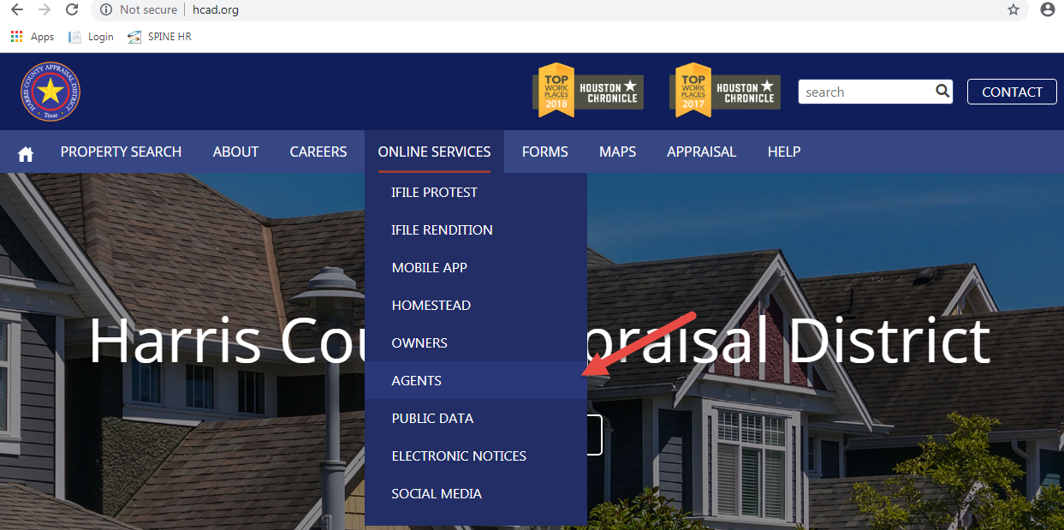
Agent Login details:-
- User Name – 00463
- Password – proptax12@@
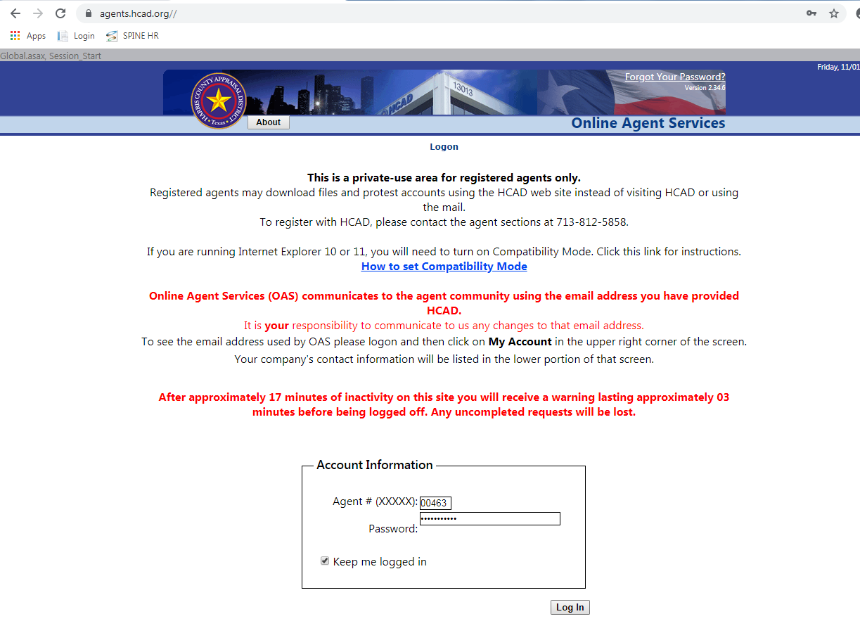
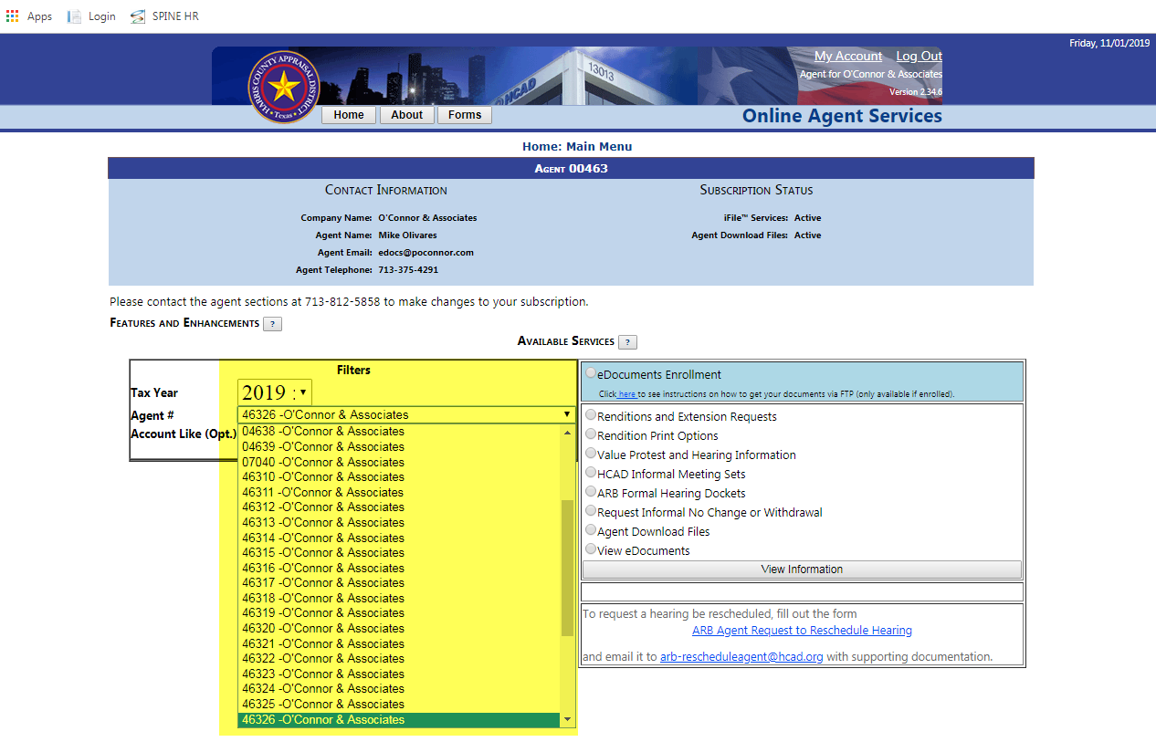
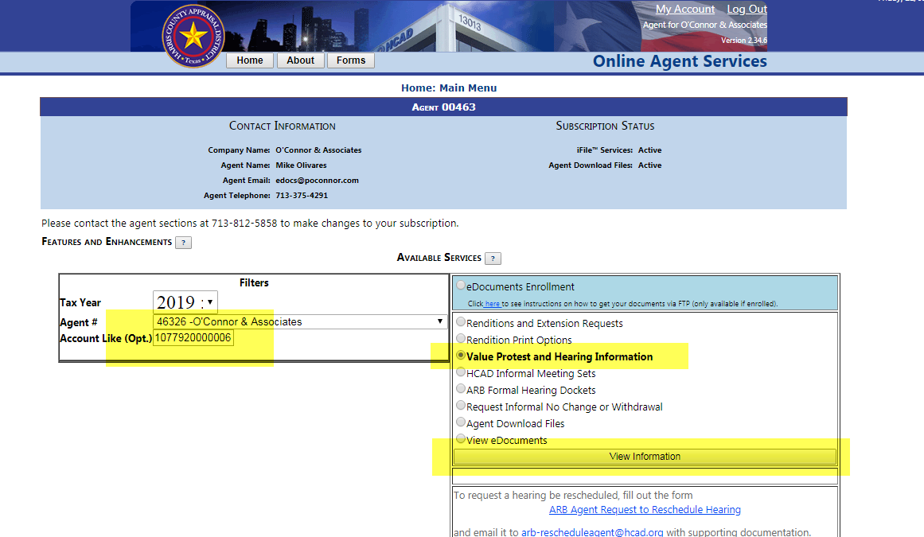
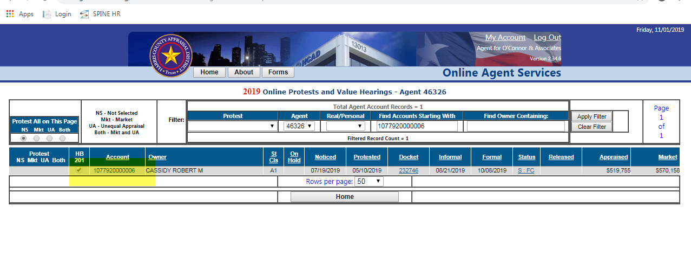

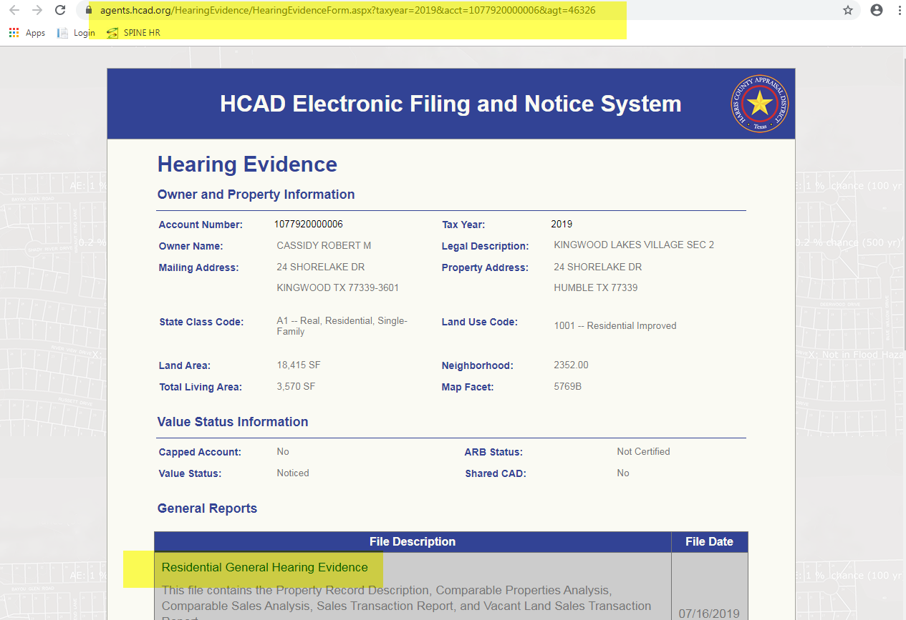
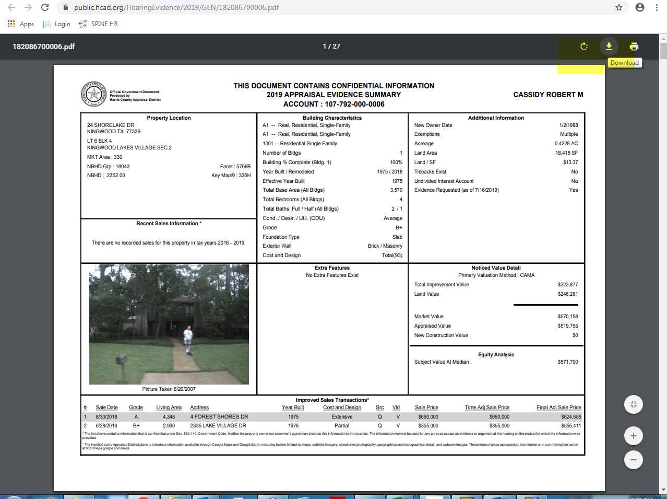
Downloaded documents will be uploaded into paperwise by using sendto option in paperwise.
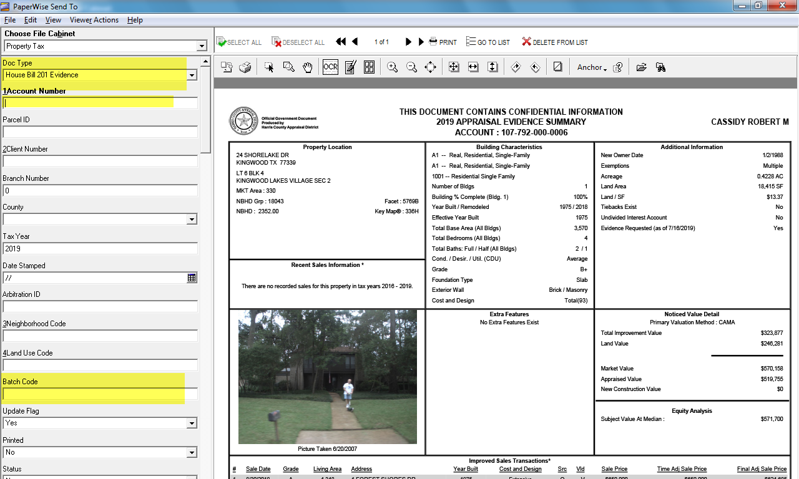

Nightcrawler Downloads:-
We run the SQL Query on daily basics to find hearing schedule accounts for running nightcrawler application from SpartaXX.
We will get the account number list for all who are active in the spartaxx account on the mentioned date. In which, we should run nightcrawler only for OCA agent ID coded accounts.
This could be confirmed by the agent ID running application. Application should be downloaded in the below link and configured in user system.
\\pfbafs\BSC\Research\MLS
Fiduciary Information details will be present in respective HCAD account page as given below in the screen shot.
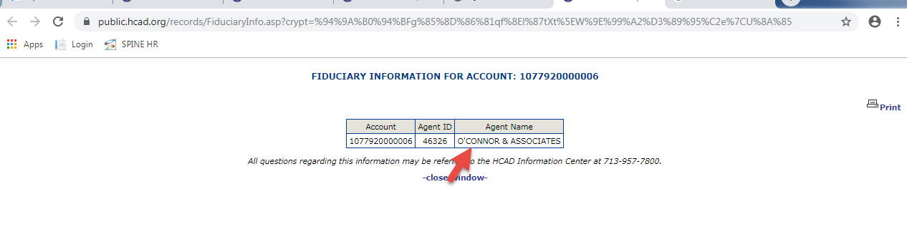
Nightcrawler application will be download the HCAD House bill automatically from HCAD agent website and upload the document to paperwise.
Once after taken OCA agent accounts we should prepare the spreadsheet with the below headers
Account number , Agent id, Tax year and scan date will be mapped manually .
Opening Nightcrawler application:-
Browse the prepared excel sheet and upload into Nightcrawler application by using upload option.
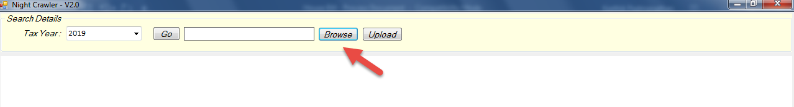
After successful runs nightcrawler will pop the message like “No.of Housebills uploaded successfully”.
Those housebills were automatically uploaded paperwise for sales processing.

HB Extractor:-
HB Extractor should be installed in user system for scrapping sales from Housebill document. HB Extractor and paperwise have linked in DB and whichever, the HB scanned in the particular date will be scrapped by HB Extractor tool.
Set up file link :- “\\pfbasql\MyPride Datafiles\Night_Crawler_Setup”
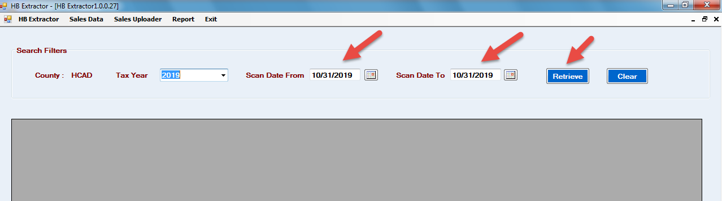

We have option while retrieves the data from Paperwise and those sales need to extracted by using Extract Sales button.
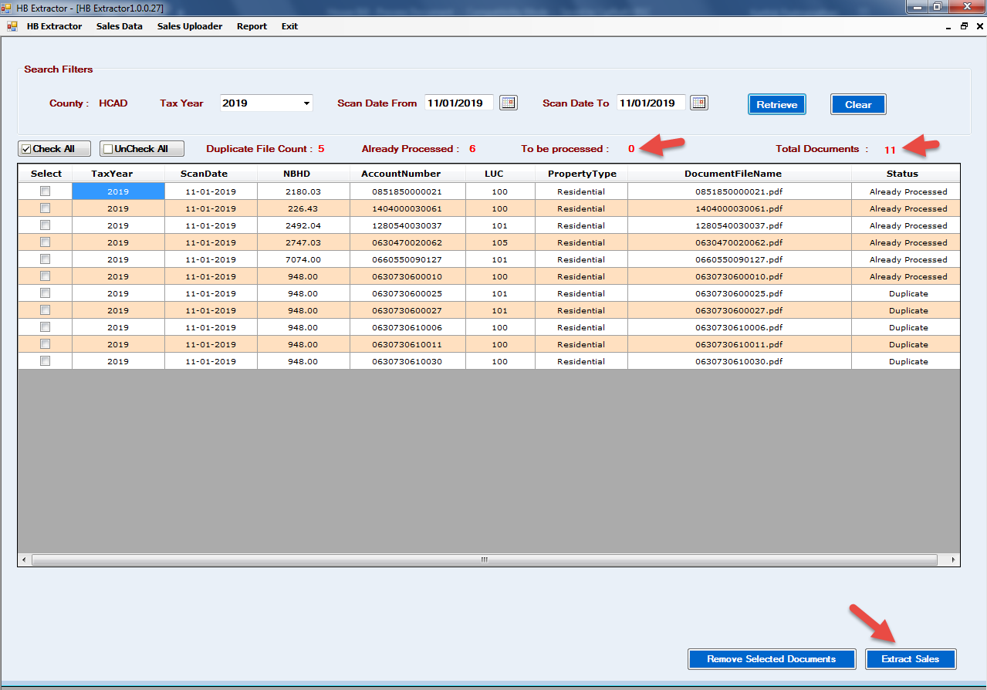
Batch Creation:-
Extracted sales information will be scrapped as Batches in sales Data link in HB Extractor. User should map the scrapped sales from recently created batch ID.
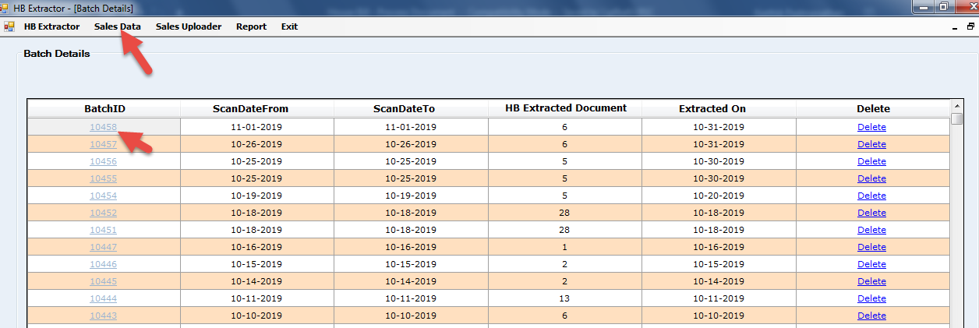
Extractor will show the scrapped log in to separate files as like below.
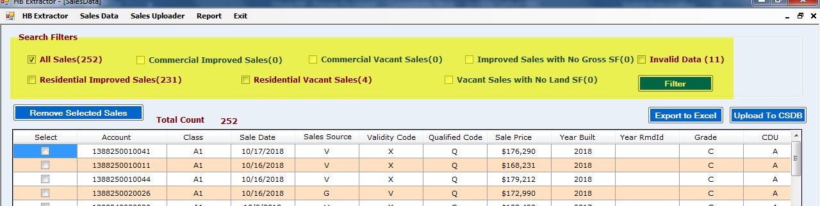
User will have filter option for each category and export the sales in Excel from “Export to Excel” Option.

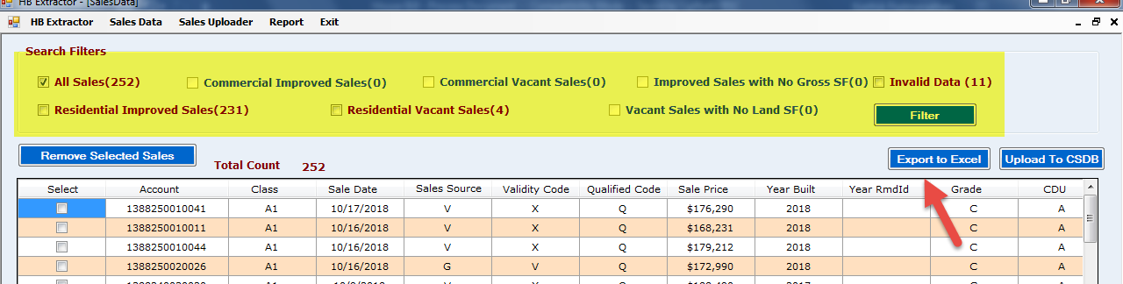
Sales PDF:-
All the separated sales saved in the pdf format in the user C drive.
By Neighborhood, for Neighborhood, IST, CVS files.
All the exported sales excel will be stored in user system and user can cross validate the excel data with the extracted pdfs which is saved in the C drive in the user machine.
Sales Excel formatting:-
Excel formatting will be done as per below table.
Random Quality is checked and following are the check points to ensure the Quality:
# | Field | Check points
1 | HB Template | The Formatted file/ uploader template should contain 121 columns.
2 | Data extract from Tool | (Source file) which is received on a daily basis from the HB Extractor tool has to verify and ensured that the respective columns are filled in a proper format.
3 | Sorce File | Ensure all relevant fields are capture from the sales document and do not miss any information that could be updated in the template.
5 | Sale Date | Filter by sort date and check for year is in (mm/dd/yyyy) format.
6 | Sale Price | Sale Price ($xxx, xxx) should always represented as “$” symbol followed by amount.
7 | Class | Filter by Class and check for extra characters, should be only 2 digits. Example it should be in(A1,F1,C1,R1)
8 | Sales Source Code | Sales source code should always contain 1 character. It will be check in PDF Example (sales source code – should be represented as Q, C, V, G) etc
9 | Validity Code | Validity code will contain only 1 or 2 characters not more than that.. It will be check in PDF ( validity code should be represented as (V,X,IF,AC,C)
10 | Qualified Code | Qualified code always contain 1 characters,. It will be check in PDF example (qualified code should be represented only Q,U)
11 | Year Built | Year Built (xxxx) less than the current year. Example ( 1972,1988,1952,1977)
12 | Level Remodel | Level Remodel should contain 2 characters. Example ( 72,88,52,77)
13 | Land Use Code | Land Use code null account needs to verify and ensure that we cross check with respective CAD.
14 | Source File | Account number blank column have to verify with source PDF
15 | Source File | Sale date null Column has to verify with the source PDF.
16 | Source File | Improvement LUC must contain GBA information ( Gross SF column should be filled )

Sales Uploads:-
All the above mentioned sales will be uploaded in sales database by using sales upload option in HB Extractor tool after formatting the excel by user.
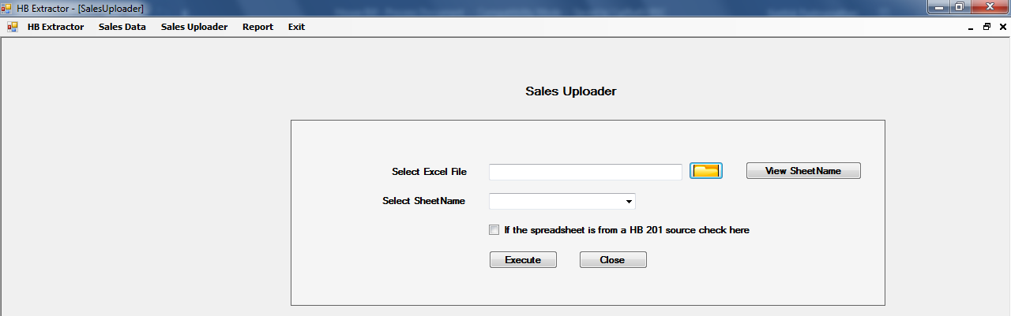

Back End Process:-
After uploading the sales, all the sales will be queued in Transactionuploaderqueue table where daily morning syn process will happen.
If syn process done, sales will be moved to Sales Table for file prep Team.

House Bill - Flow Chart Representation
Start

Receiving the Job Notification from Houston team, Ptax team, Night crawler software – which Contains House Bill source file - Scanned Date and Tax year details

HB Extractor Ver 1.0.0.8
file: \\pfbasql\MyPride_Datafiles\HB_27_Jun_2019
Open the HB Extractor. HB Extractor is a Tool used to extract the HB Information.

Click the HB Extractor Tab – Search Filters Contains Tax Year and Scan Date Range.

Input: Received Scan Date Range and Tax Year

 Click this Button

House Billing Information’s are retrieved. It Contains Four Category
- Duplicate File Count
- Already Processed
- To be Processed
- Total Documents

 Click this Button

Batch ID is generated for scanned Date Range and Tax year. Click this particular Batch ID then scanned Date range Comparable is viewed

It contains Some Searching criteria.
- All Sales, Commercial Vacant Sales, Residential Improved Sales, Residential Vacant Sales, Invalid data, NO GBA, Vacant sale NO Land

Click Unchecked All Sales
Click NO GBA
Click Invalid data
Click Residential Vacant Sales

Click Residential Improved Sales

Click Commercial Vacant Sales

Click this button
Click this button
Click this button

Click this Button
Click this Button
Click this Button

Exported Excel Saved to respective Common path

For the sales PDF will be saved in local disk(c) , Extracted documents, Downloading templates

Process the Exported Excel with Compare to the Pdf Comparable. Fill the missing fields.

Upload the Processed Document to the CSDB

Success Failed
Uploaded
End

Re-Check and Upload
Successfully Uploaded

House Bill
- We extract the comparable in HB Extractor by giving the date as mentioned in the job notification received.
- Each extracted comparable will be cross checked with the given House bill. We modify the fields if it is wrong.

- The cross checked comparable template will be loaded into the database using the same HB extractor.

- The HB extractor can be Installed in the below link And It will Installed in Internet Explorer 11
file: \\pfbasql\MyPride_Datafiles\HB_27_Jun_2019
- Received and worked data will be saved in
\\pfbafs\\BSC\\Research\MLS\House_Bill

